Pediatrics
February 8, 2018
Dear Dr. Lewis,
I am sending you our manuscript entitled “Pain relieving interventions for retinopathy of prematurity: A Meta-analysis” by Disher, Cameron, Mitra, Cathcart, and Campbell-Yeo. We would like to have our manuscript considered for publication in Pediatrics.

In this network meta-analysis, we combine all available direct and indirect evidence regarding pain relieving interventions for retinopathy of prematurity eye exams. By reporting relative and absolute outcomes for pain assessment scales we illustrate that there is an urgent need for novel pain relieving strategies in this population. We believe this work would have significant appeal to the readership of Pediatrics.
This review is being submitted only to Pediatrics, it will not be submitted elsewhere while under consideration, and, should it be published in Pediatrics, it will not be published elsewhere – either in similar form or verbatim – without the permission of the editors.

All authors are responsible for reported results and have participated in the concept and design, analysis and interpretation of data, drafting or revising, and have approved this manuscript as submitted. None of the authors have any conflicts of interest to declare.
Thank you for your consideration of our work. We look forward to hearing from you at your earliest convenience.
Sincerely yours,
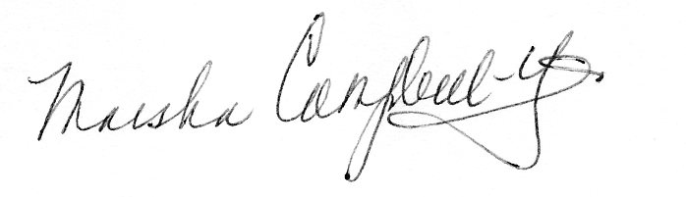
Marsha Campbell-Yeo PhD NNP-BC RN
Associate Professor and Clinician Scientist, School of Nursing, Faculty of Health Professions and Departments of Pediatrics, Psychology and Neuroscience, Dalhousie University, and Faculty, Centre for Pediatric Pain, IWK Health Centre
5869 University Avenue, PO Box 15000, Halifax Nova Scotia, B3H 4R2
902.494.4283
marsha.campbell-yeo@dal.ca

